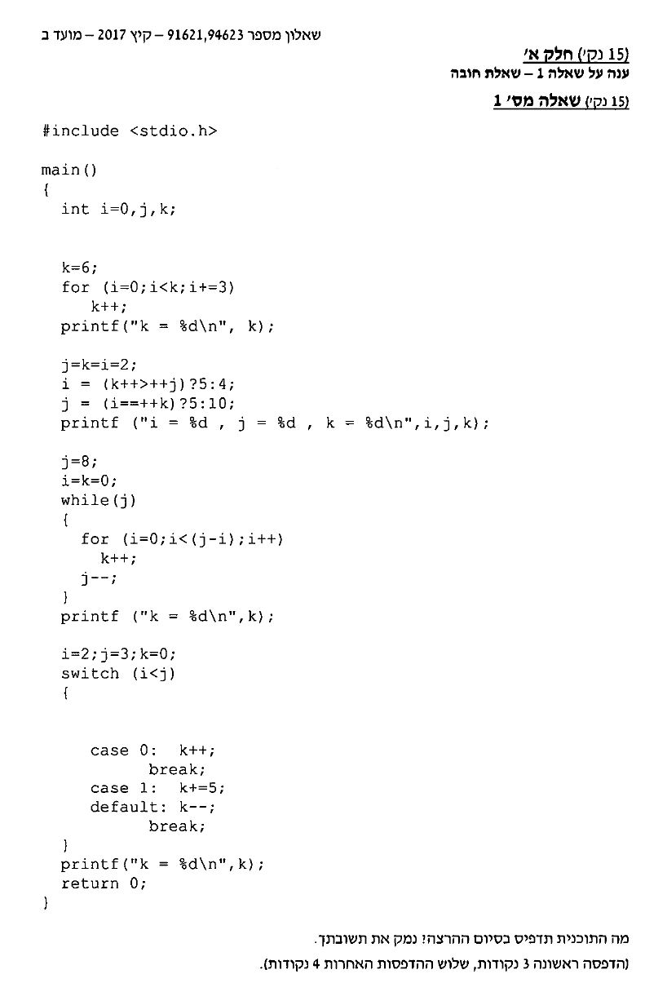

תשובה :

#include <stdio.h>

// Answer 1: write what the program does:

void main()

{

int i = 0, j, k; // i=0,j = uninitialized, k=6;

k = 6;

for (i = 0; i < k; i += 3) // i<6 i=0 ,k=7**.** i=3, k=8**.** i=6, k=9

k++;

printf("%d k= %d\n",&i, &k); // check i

j = k = i = 2; // j=k=i=2

i = (k++ > ++j) ? 5 : 4; // k+=1, j=3 no. i=4. k=3,j=3,i=4

j = (i == ++k) ? 5 : 10; // k=4. i==4. 5. j=5.

printf("i = %d , j = %d, k = %d\n", i, j, k); // print: i=4, j=5, k=4

j = 8; // j=8, i= 0, k=0

i = k = 0;

while (j) { // 8 rounds.

for (i = 0; i < (j - 1); i++) // i<7 - will go 7 rounds. k=7

k++;// i<6 - k=6+7 = 13. // i<5 = 13+5=18.

// i<4 = 18+4=22. //i<3 = 22+3=25. //i<2 = 27. +1 =28

j--;

}

printf(" k = %d\n", k); // print: k=28. !7

i = 2, j = 3, k = 0; // i=2, j=3, k=0:

switch (i < j) { // switch(2<3): true=1:

case 0: k++;

break;

case 1: k += 5; // case 1 = true: k+=5: k=5.

default: k--; // default= will work. because there is no break in case 1. k=4. break.

break;

}

printf("k = %d\n", k); //print: k=4

getchar();

}